Uploading Digital Objects to Hyrax

1. Go to Hyrax and login, or create an account and request uploading access
   1. use your Albany.edu email
   2. Let Greg know when you create an account and return when you have upload permissions.
2. Once you have upload permissions, go to Arclight, find the file that represents the digital object you want to upload. From the URI, copy the long string of letters and numbers right after the “aspace_”. This is the unique ArchivesSpace ID for that record.
   1. Notice the collection ID is in the URI as well.

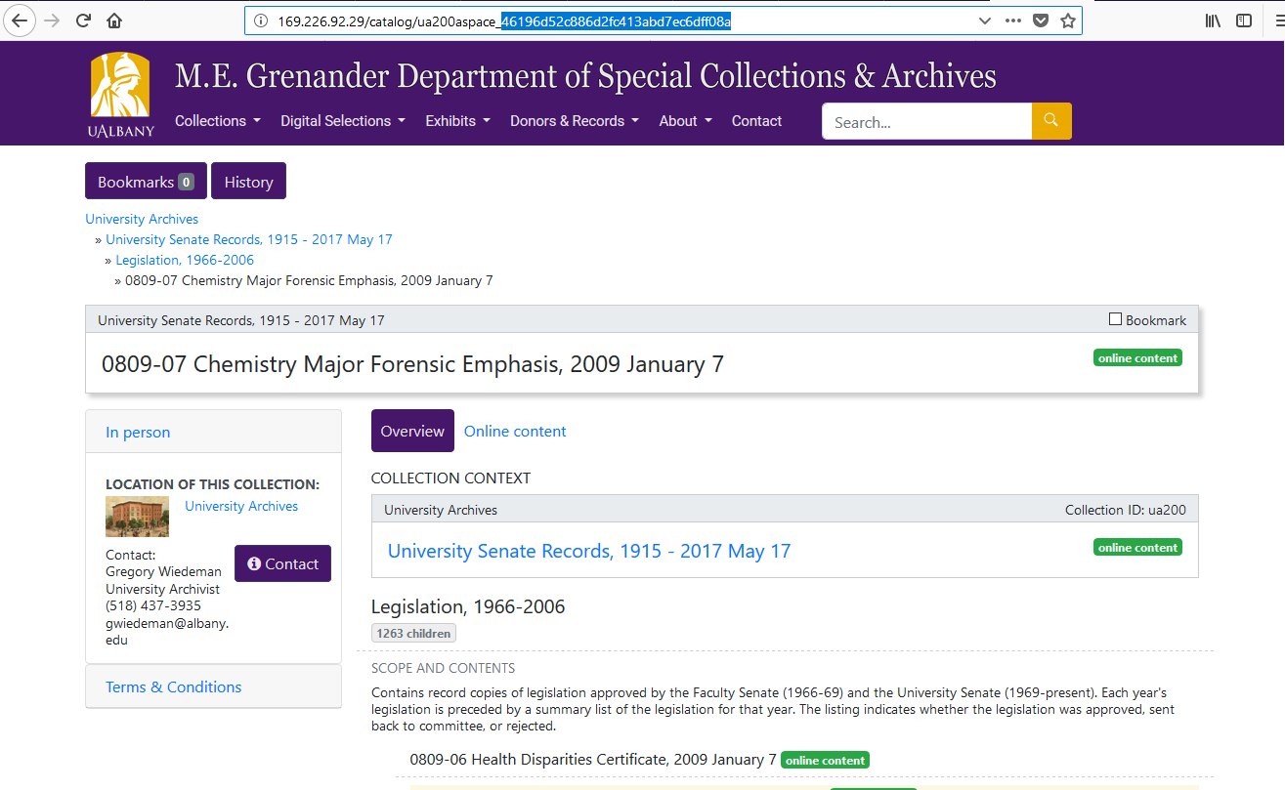

1. In your Dashboard, select “Works” on the left side menu

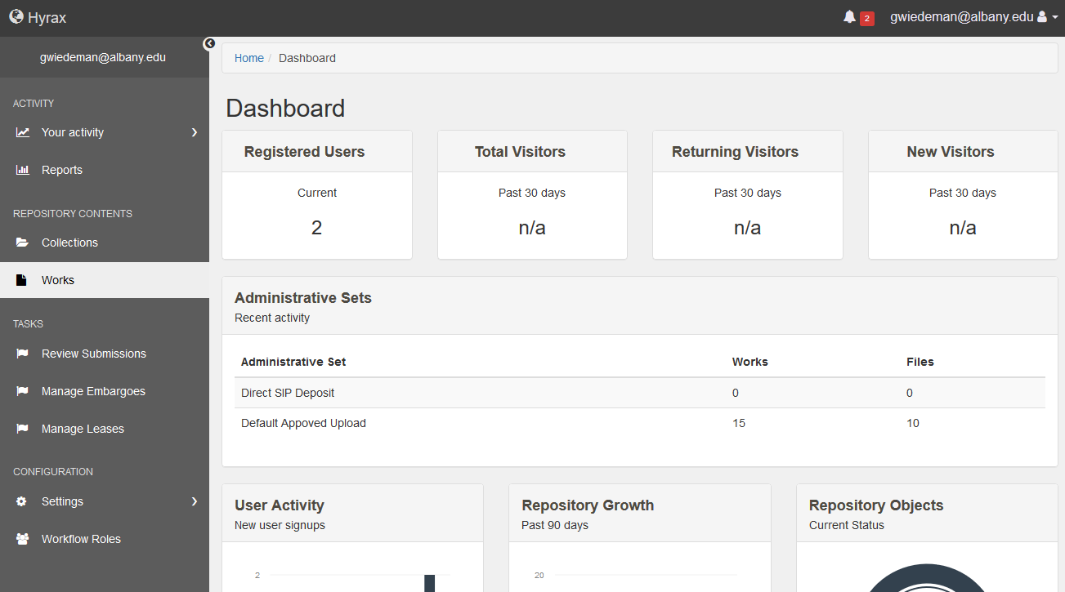

1. Select the “Add new work” button on the right side

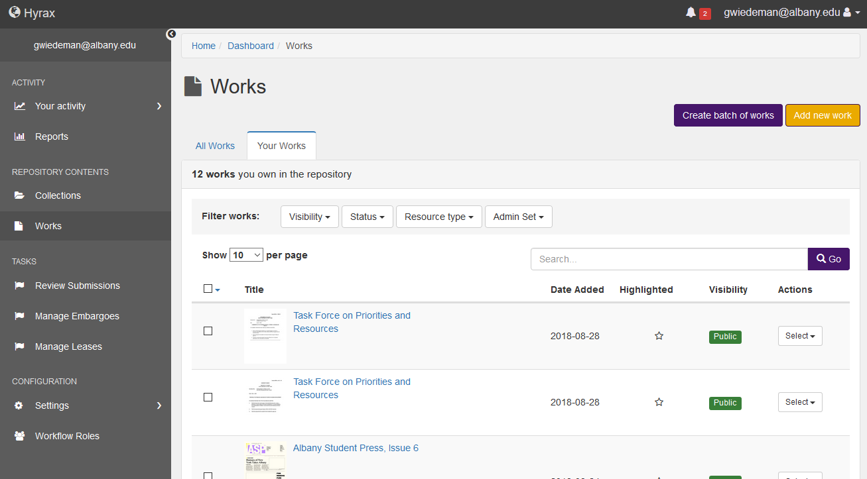

1. For most cases, select “Digital Archival Objects” and then the “Create Work” button.

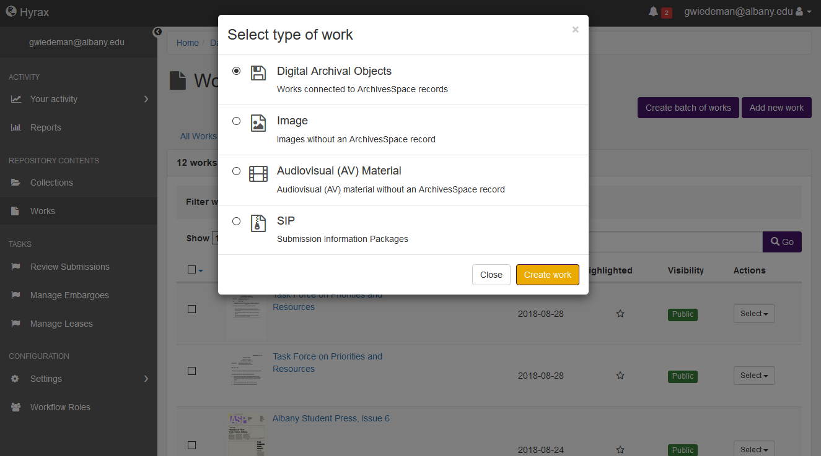

1. In the “Descriptions” tab, enter only the ArchivesSpace ID, and the Collection number

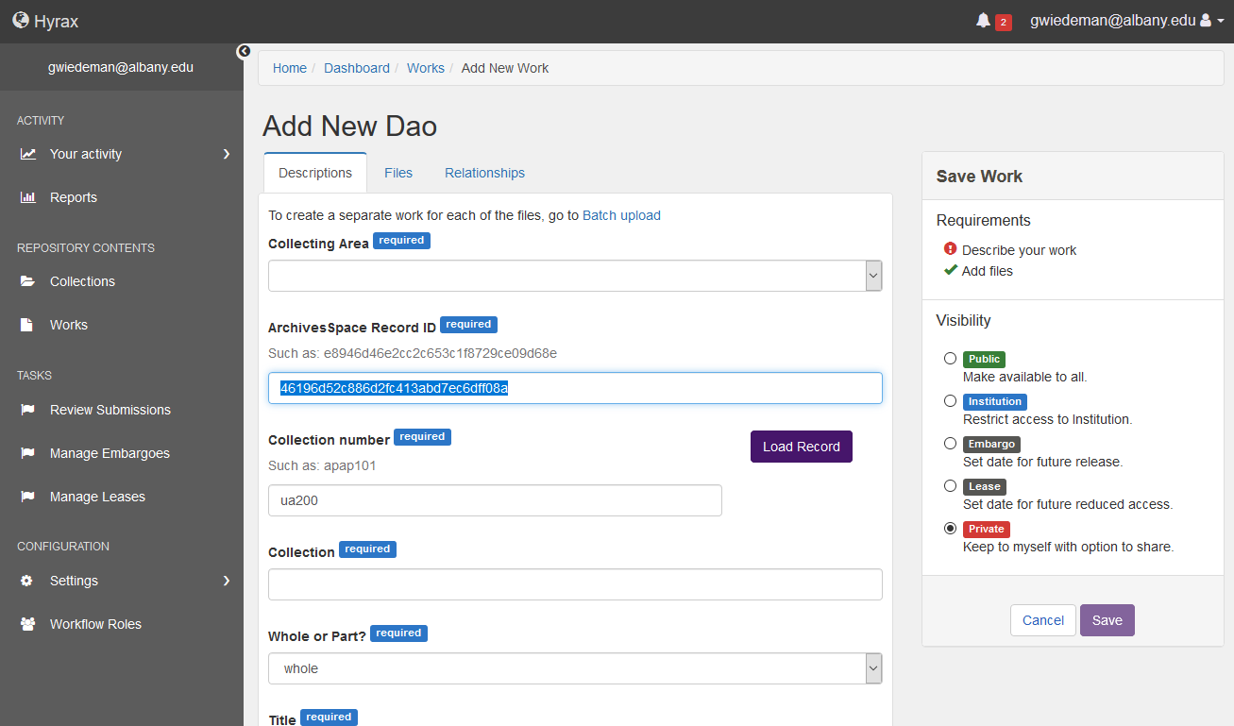

1. Select the “Load Record” button to pull additional metadata from Arclight

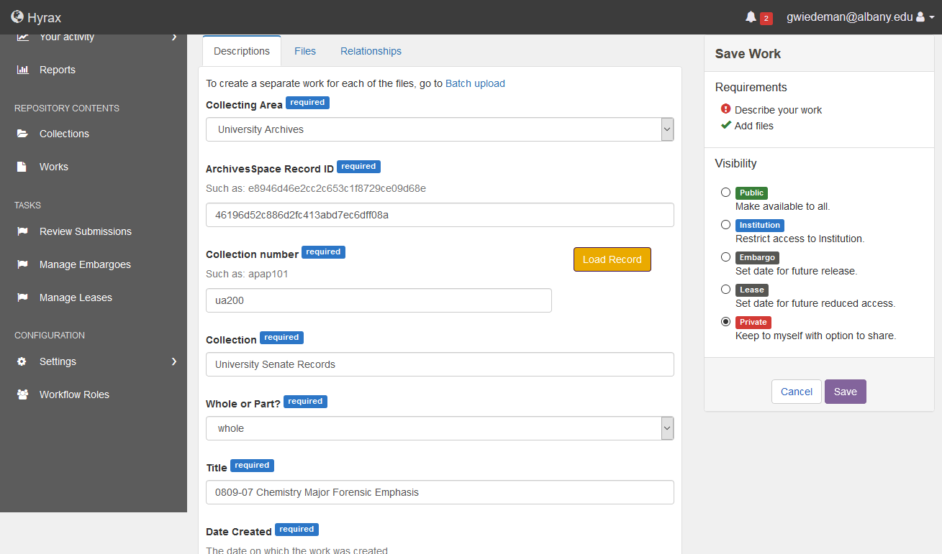

1. Add additional Metadata, Resource Type and Rights Statement is required, while “Additional fields”  
    are not

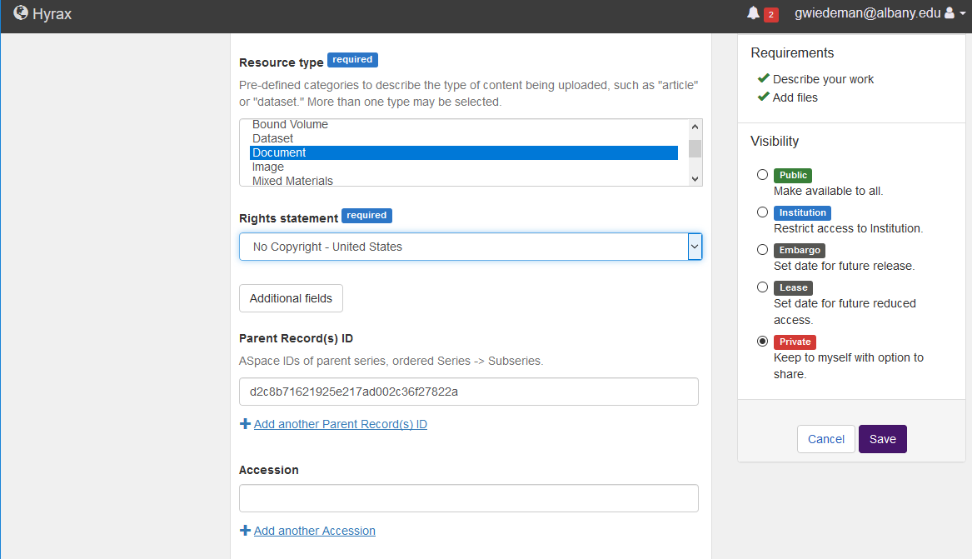

1. In the “Files” tab, browse and upload any files represented by the Arclight record. These can be PDFs, Office documents (doc, docx, ppt, xlsx, etc.), or any image file.

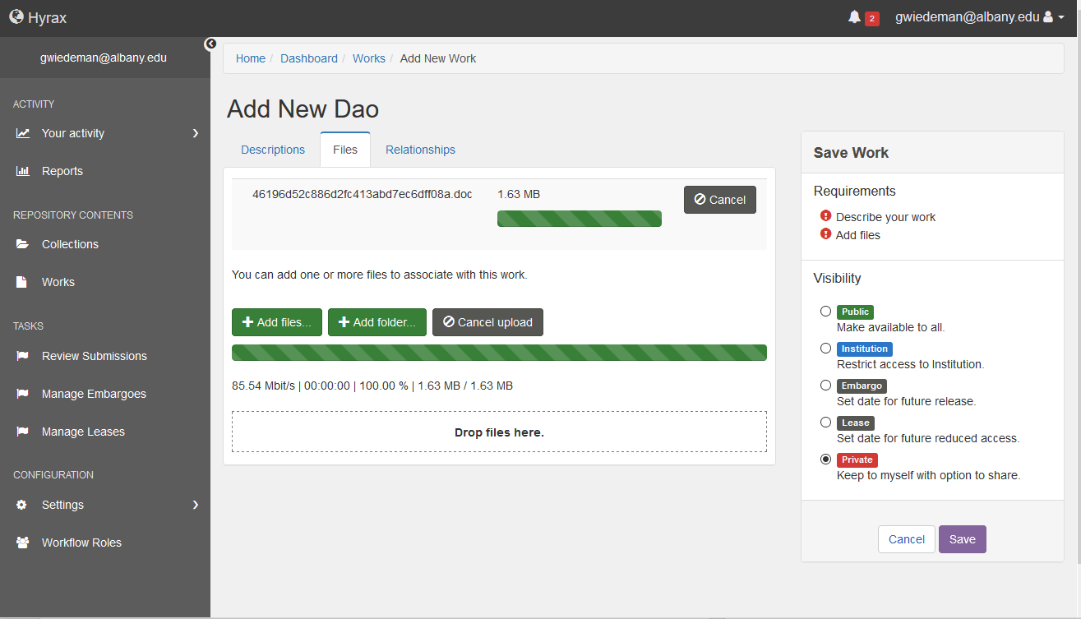

1. Select the Visibility of the work on the right side, and Save the work.

